Technology Program: Design Cycle Booklet
Name: Grade:

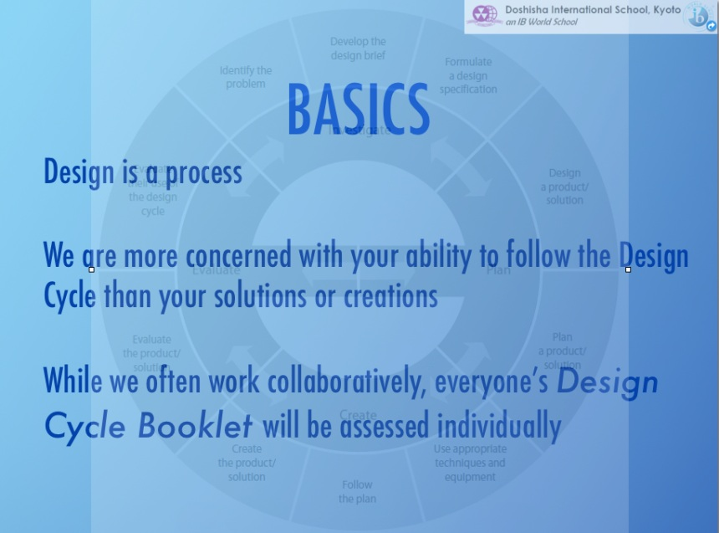

Part A: Investigate
Part B: Plan 1 Design
Part C: Plan
Part D: Create
Part E: Evaluate
Unit Question: How can large amounts of information be
presented visually to make big ideas more easily accessible?
PART A: INVESTIGATE
Identifying the Problem to be Solved
1. After a discussion with the class state the problem in your own words.

__________________________________________________________________________________________________________________________________________________________
__________________________________________________________________________________________________________________________________________________________
Developing a Design Brief
An INFOGRAPHIC is a visual representation of information.
- WHAT does a good one look like? WHERE can you find out?
- It requires consideration of the ELEMENTS OF DESIGN. WHERE can you reference these?
- WHERE will you find creative commons work?
- CAN you make your own images?
Areas of research you need to undertake.
 | What you need to find out | Where you will find it  Examples  X The internet  O http://www.dezineguide.com/tutorial/20-best-infographics-tutorials-and-articles/
1
2
3
4

Formulating a Design Specification
What requirements must your product/solution meet? Write as statements. Number them.
YOU MAY CHOOSE 3 FROM ELEMENTS OF DESIGN YOU WILL FOCUS ON
A good infographic…
1
2
3
4
5
6

2. Design tests to evaluate the success of the product/solution.
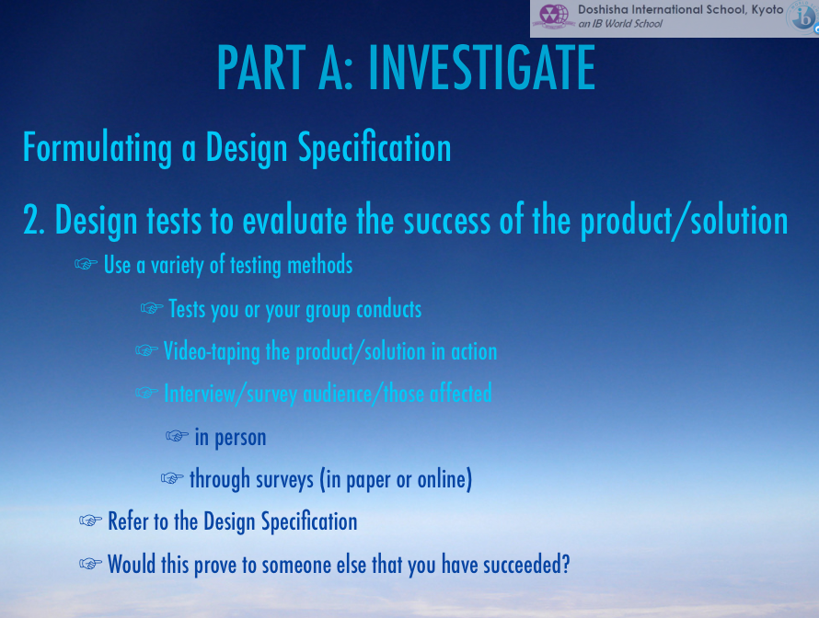
THESE MAY BE THE SAME TEST DONE BY A DIFFERENT PERSON
TEST 1

TEST 2

Evaluating your Use of the Design Cycle
- On a scale of 1-3 (1 is poor, 3 is good), evaluate your performance at each stage of the design cycle and suggest ways you could improve using the table below. Refer to the rubric.

Design Cycle Stage |  | Evaluation
PART A: Investigate
How can you improve?
PART B: DESIGN
Designing the Product/Solution
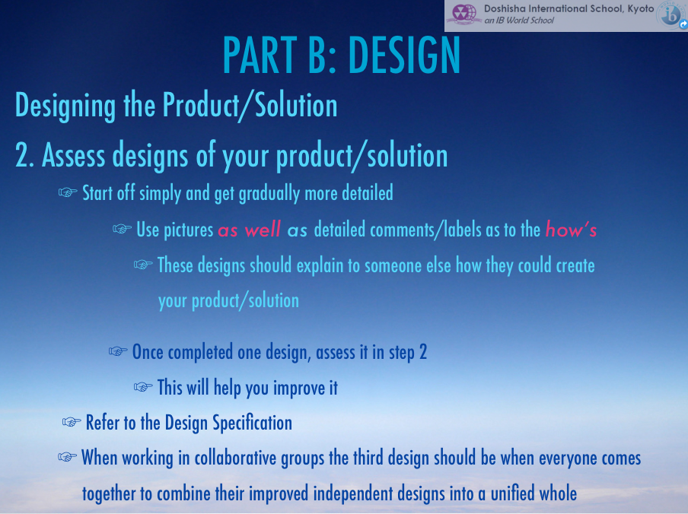

- Create designs of your product/solution.
Consider:
- a layout that is easy to use
- menu bar titles that are clear
- information is laid out with colours that are easy on the eyes
- text, video image balance
DESIGN 1
DESIGN 2
DESIGN 3
- Using a scale of 1-3 (1 is poor, 3 is good), rate each design against the design specifications using the chart below and then rate the design overall.
Design Specification | Design 1 | Design 2 | Design 3
1.
2.
3.
4.
5.
6.
7.
8.
9.
10.
Overall Rating

3. Which design will you use to create your product? Write a paragraph explaining why you have chosen this final design.
__________________________________________________________________________________________________________________________________________________________
__________________________________________________________________________________________________________________________________________________________
__________________________________________________________________________________________________________________________________________________________
__________________________________________________________________________________________________________________________________________________________
Evaluating your Use of the Design Cycle
- On a scale of 1-3 (1 is poor, 3 is good), evaluate your performance at each stage of the design cycle and suggest ways you could improve using the table below. Refer to the rubric.
Design Cycle Stage |  | Evaluation
PART B: Plan 1 (Design Focus)
How can you improve?
PART C: PLAN
Planning the Product/Solution
1. What steps are needed to create the product/solution according to your design?
2. Use the table below to make a plan to create your product/solution that makes good use of resources and time.
You will have to explain any changes you make to this plan
Step | Resources Needed | Time Needed

3. Evaluate the effectiveness of your plan by answering the following questions:
Question | Yes/No
Will you be able to complete the product/solution in the amount of time available?
Are the tools and resources available to make the product/solution?
Evaluating your Use of the Design Cycle
- On a scale of 1-3 (1 is poor, 3 is good), evaluate your performance at each stage of the design cycle and suggest ways you could improve using the table below. Refer to the rubric.
Design Cycle Stage |  | Evaluation
PART C: Plan
How can you improve?

PART D: CREATE
Following the Plan
- Use the table below to evaluate your progress against the plan. Use the right column to explain and justify any changes (if necessary) from the original plan.
Date | Step of Plan | Completed | Do any changes need to be made to your plan? Explain/justify.

Evaluating your Use of the Design Cycle
- On a scale of 1-3 (1 is poor, 3 is good), evaluate your performance at each stage of the design cycle and suggest ways you could improve using the table below. Refer to the rubric.

Design Cycle Stage |  | Evaluation
PART D: Create
How can you improve?

PART E: EVALUATE
Evaluating the Product/Solution
- Using the test you designed in PART A, use this space to record the results. Remember to note the source of the results.
WHO was the subject of the test?
HOW were results collected and any other pertinent information.
Testing results
1
2
- What impact will your product/solution have? Who will be affected and how?

____________________________________________________________________________________________________________________________________________________________________________________________________________________________________________________________________________
- How could your product/solution be improved?
- ____________________________________________________________________________________________________________________________________________________________________________________________________________________________________________________________________________

Evaluating your Use of the Design Cycle
- On a scale of 1-3 (1 is poor, 3 is good), evaluate your performance at each stage of the design cycle and suggest ways you could improve below.
Design Cycle Stage | Evaluation
PART E: Evaluate
How can you improve?

_______________________________________________________________________________________________________________________________________________________________________________________________________________________________________________________________________________________________________________________________________________________________________________________________________________________________________________________________________________________________________________________________________________________________________________________________________________________________________________________________

