Technology Program: Design Cycle Booklet
Name: Grade:

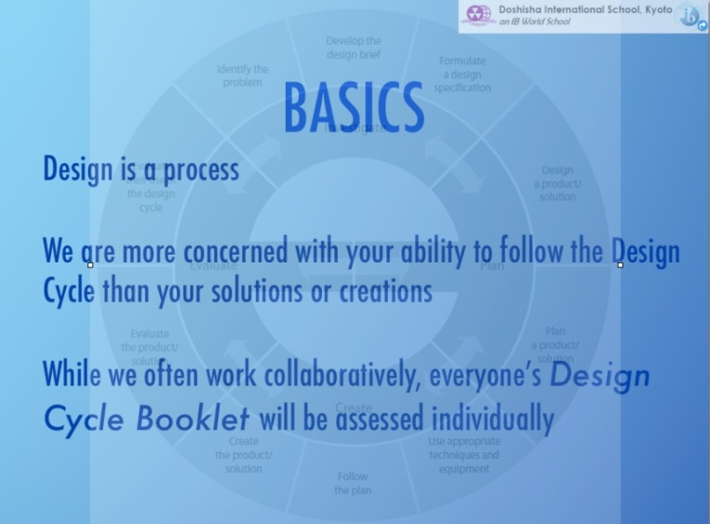
Part A: Investigate
Part B: Plan 1 Design
Part C: Plan
Part D: Create
Part E: Evaluate
Part F: Attitudes in Technology

Unit Question: How has communication changed through time?
Problems
- We have a Student Led Conference coming up and need to share two Learner Profile Portfolio pieces beforehand. We have the assignment of collecting comments on them online.
- We need to trial a cloud based design Cycle Booklet to see if it helps us increase performance in technology classes.
- As we progress through the unit we will be discovering new ways of using our products/solutions to solve other related problems and improve our efficiency as learners.
PART A: INVESTIGATE
Identifying the Problem to be Solved
1. What other problems might be associated with possible solutions to these? How can we manage both solutions together in a new way?

__________________________________________________________________________________________________________________________________________________________
__________________________________________________________________________________________________________________________________________________________
Developing a Design Brief
In order to share
- WHAT does a good wiki look like? WHERE can you find out?

 | Wiki site research by topic  Choose a topic of interest and do a Google search for it with the word “wiki” after it. | Where you will find it  Examples  X The internet  O http://www.dezineguide.com/tutorial/20-best-infographics-tutorials-and-articles/
1
2
3

Notes for your areas of research go here
 | Wiki site | Good points to consider using
1
2
3

Formulating a Design Specification
What requirements must your product/solution meet? Write as statements. Number them.

Refer to the your statement of the problem to decide what successful solutions to these problems look like.
Learner Profile Sharing
1
2
3
Online Design Cycle Booklet
4
5
6

2. Design tests to evaluate the success of the product/solution.
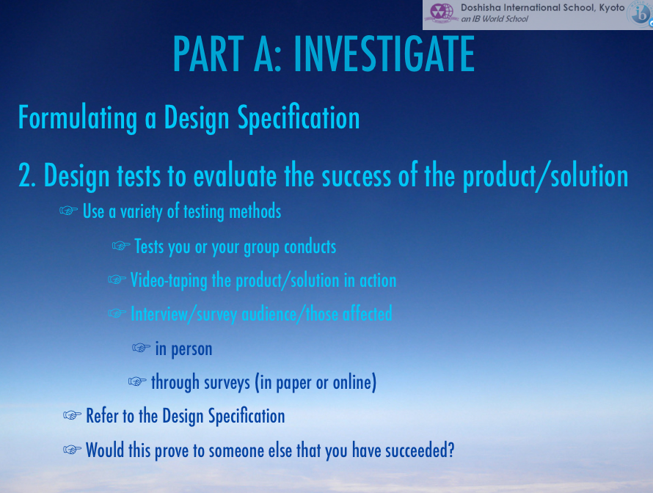

In order to illustrate how best to word questions for tests YOU will be the intended audience for this unit. Devise questions based on the design specification we made in class. ALL aspects must have questions. EACH NUMBERED DESIGN SPECIFICATION DETAIL MUST HAVE A QUESTION AND BE ANSWERED ON YOUR WIKI.

TEST QUESTIONS

Evaluating your Use of the Design Cycle
- On a scale of 1-3 (1 is poor, 3 is good), evaluate your performance at each stage of the design cycle and suggest ways you could improve using the table below. Refer to the rubric.

Design Cycle Stage |  | Evaluation
PART A: Investigate
What went well?

What could go better?
PART B: DESIGN
Designing the Product/Solution
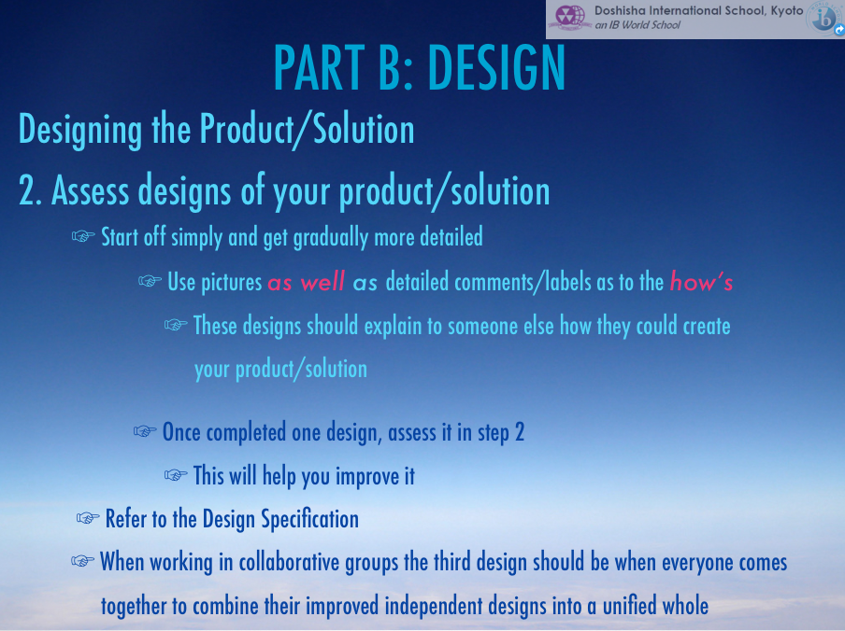
- Create designs of your product/solution.
Consider:
- a layout that is easy to use
- menu bar titles that are clear
- information is laid out with colours that are easy on the eyes
- text, video image balance
DESIGN 1
DESIGN 2
DESIGN 3

Assessment of Design (Based on the Design Specification)
- Using a scale of 1-3 (1 is poor, 3 is good), rate each design against the design specifications using the chart below and then rate the design overall.
Design Specification | Design 1 | Design 2 | Design 3
1.
2.
3.
4.
5.
6.
7.
8.
9.
10.
Overall Rating

3. Which design will you use to create your product? Write a paragraph explaining why you have chosen this final design.
__________________________________________________________________________________________________________________________________________________________
__________________________________________________________________________________________________________________________________________________________
__________________________________________________________________________________________________________________________________________________________
__________________________________________________________________________________________________________________________________________________________
Evaluating your Use of the Design Cycle
- On a scale of 1-3 (1 is poor, 3 is good), evaluate your performance at each stage of the design cycle and suggest ways you could improve using the table below. Refer to the rubric.
Design Cycle Stage |  | Evaluation
PART B: Plan 1 (Design Focus)
What went well?

What could go better?
PART C: PLAN
Planning the Product/Solution
1. What steps are needed to create the product/solution according to your design?
2. Use the table below to make a plan to create your product/solution that makes good use of resources and time.
You will have to explain any changes you make to this plan
Step | Resources Needed | Time Needed

3. Evaluate the effectiveness of your plan by answering the following questions:
Question | Yes/No
Will you be able to complete the product/solution in the amount of time available?
Are the tools and resources available to make the product/solution?
Evaluating your Use of the Design Cycle
- On a scale of 1-3 (1 is poor, 3 is good), evaluate your performance at each stage of the design cycle and suggest ways you could improve using the table below. Refer to the rubric.
Design Cycle Stage |  | Evaluation
PART C: Plan
What went well?

What could go better?

PART D: CREATE
Following the Plan
- Use the table below to evaluate your progress against the plan. Use the right column to explain and justify any changes (if necessary) from the original plan.
Date | Step of Plan | Completed | Do any changes need to be made to your plan? Explain/justify.

Evaluating your Use of the Design Cycle
- On a scale of 1-3 (1 is poor, 3 is good), evaluate your performance at each stage of the design cycle and suggest ways you could improve using the table below. Refer to the rubric.

Design Cycle Stage |  | Evaluation
PART D: Create
What went well?

What could go better?

PART E: EVALUATE
Evaluating the Product/Solution
- Using the test you designed in PART A, use this space to record the results. Remember to note the source of the results.
WHO was the subject of the test?
HOW were results collected and any other pertinent information.
Testing results
1
2
- What impact will your product/solution have? Who will be affected and how?

____________________________________________________________________________________________________________________________________________________________________________________________________________________________________________________________________________
- How could your product/solution be improved?
- ____________________________________________________________________________________________________________________________________________________________________________________________________________________________________________________________________________

Evaluating your Use of the Design Cycle
- On a scale of 1-3 (1 is poor, 3 is good), evaluate your performance at each stage of the design cycle and suggest ways you could improve below.
Design Cycle Stage | Evaluation
PART E: Evaluate
What went well?

What could go better? How can you improve?

_________________________________________________________________________________________________________________________________________________________________________________________________________________________________________________________________________________________________________________________________________________________________________________________________________________________________________________________________________________________________________________

